Dave Dodge, L.C.S.W.

Helping People Get Better Faster

128 Radio Circle Mt. Kisco, N.Y. 10549

dave@acceleratedhealingsolutions.com (914) 242-3484

www.AcceleratedHealingSolutions.com www.BrainspottingSpecialist.com
_______________________________________________________________________________________________________________________________________

Best Types of Journaling for Emotional Healing

The two best ways to express your emotions (both positive and negative) are Gratitude Journaling and Emotional Release Journaling. Both are very effective in healing our emotional wounds.

Gratitude Journal: This is a highly effective strategy for relieving stress because it helps you to focus on the resources you have in your life already and create a more positive mood in the moment, both of which have been shown to build long-term resilience.

Emotional Release Journal: You may also write about your emotional responses to events that have happened throughout the day as a way of coping with the stress. This can help you to process what you are feeling and perhaps even explore more positive reframing options.

Below are two excellent articles on these types of Journaling. The first article is 13 pages long so to get to the Emotional Release Journal information you will have to scroll down. Enjoy!

______________________________________

1st article

Gratitude Journal: 67 Templates, Ideas, and Apps for Your Diary

by Courtney Ackerman
As we express our gratitude, we must never forget that the highest appreciation is not to utter words, but to live by them. – John F. Kennedy
Gratitude is like most desirable traits and qualities in that it is usually not enough to simply decide to be grateful – we must actively practice it to cement its place in our lives.
There are many reasons why gratitude is such a desirable quality, aside from its inherent goodness. As we recently wrote in a piece on the benefits of gratitude, performing simple daily acts of gratitude can have a big impact on your health and happiness.
These effects are particularly evident in the practice of gratitude journaling. It only takes a few minutes a day, but it can give you a lasting mood boost that can take you from feeling “okay” to feeling “great” on a more regular basis.
If you’re wondering what a gratitude journal is or how you can jump on the journaling train, read ahead to learn everything you need to know about keeping a gratitude journal!

This article contains:
- What is a Gratitude Journal?

- What is the Difference Between a Gratitude Journal, Planner, Diary, and Notebook?
- Ideas for Items in Your Gratitude Log

- The Gratitude Bullet Journal

- Writing a Gratitude Essay

- Printable Journal Templates (go to website to download)

- 5 Gratitude Journal Apps That Can Help

- References (go to website to download)

What is a Gratitude Journal?
A gratitude journal is, quite simply, a tool to keep track of the good things in life. No matter how difficult and defeating life can sometimes feel, there is always something to feel grateful for.
While it can be tough to find something to be grateful about in a rough patch, it’s not just another “easy to say, but hard to do” action – it can actually help pull you out of your funk.
Even more than that, regularly journaling about the good things in your life can help prepare and strengthen you to deal with the rough patches when they pop up.
It’s extremely simple to start: simply write down (or type) the things you are grateful for on a daily basis. You can use a journal, diary, notebook, or just a piece of paper. If you’re committed to being green or just find it easier to do things digitally, you can use one of the many gratitude apps or even a simple Word document totally the good things!
Once you have your journal or app ready, simply start noting the things you are grateful for.
Got a promotion? Journal it!
Mastered a new yoga move? Journal it!
Received good news about a potential health problem? You guessed it – journal it!
It really is that easy.
In case you’re wondering “What, exactly, will this practice do for me?” – read on to learn about the potential benefits of this simple practice.

Benefits of a Gratitude Journal
We wrote about the benefits of a regular gratitude practice here, but here are a few benefits people have noticed when practicing gratitude journaling in particular:
- Gratitude journaling, like many gratitude practices, can lower your stress levels.
- It can help you feel calmer, especially at night.
- Journaling can give you a new perspective on what is important to you and what you truly appreciate in your life.
- By noting what you are grateful for, you can gain clarity on what you want to have more of in your life, and what you can do without.
- Gratitude journaling can help you find out and focus on what really matters to you.
- Keeping a gratitude journal helps you learn more about yourself and become more self-aware.
- Your gratitude journal is for your eyes only, so you can write anything you feel without worrying about judgment from others.
- On days when you feel blue, you can read through your gratitude journal to readjust your attitude and remember all the good things in your life. (Jessen, 2015)
A yoga enthusiast at Yoganonymous.com wrote about seven of the benefits he noticed when gratitude journaling:
- It can make you more mindful, helping you to become more grounded and also making it easier to notice even more things you are grateful for! (To read about the many, related benefits of mindfulness, click here!)
- Gratitude journaling can help you feel more balanced and less thrown off by daily stress.
- You may notice that a lot more small, good things are happening – or maybe you’ll notice the small, good things that were already happening!
- Your gratitude might act as a beacon to good things and good people, drawing even more positive things to be grateful for to you.
- It can make you feel accomplished, even if it’s a relatively small accomplishment. We all need a win, no matter how big or small, every now and then!
- Beware – it might just make you more giving and generous to others! But don’t worry, it isn’t always about money; paradoxically, there are things that actually grow and increase when we give them away, like compassion, empathy, and laughter!
- Gratitude journaling can provide a sense of context or interconnectedness. It can remind us how things in life are connected to one another, and guide us to one of those rare moments of epiphany in which we truly recognize that the word is so much bigger than us, yet we are grateful just to be a small part of it. (Pope, 2016).
If you’re the kind of person who wants that cold, hard evidence in addition to accounts of personal experience, there are studies that back these observations:
- A brand new study of a three-month trial of gratitude journaling found that both reflective (finding things to be grateful for) and reflective-behavioral (finding things to be grateful for and expressing your gratitude) journaling have a significant, positive impact on well-being, affect, and depression (O’Connell, O’Shea, & Gallagher, 2017).
- Another brand new study showed that Turkish freshmen who completed a three-week gratitude journal experienced greater gratitude, better adjustment to university life, higher life satisfaction, and enhanced positive affect, compared to a control group of freshmen (Işık & Ergüner-Tekinalp, 2017).
- Gratitude journaling has even been shown to help divorced parents forgive their ex-spouse(s), an extremely important step towards positive co-parenting (Rye, Fleri, Moore, Worthington, Wade, Sandage, & Cook, 2012).
- Finally, researchers in Australia found evidence that gratitude journaling helped school leaders foster a balanced view of the good and bad things that happen at school, use more appreciative problem solving, find value in school-based relationships, and experience more positive emotion, ultimately making them better and happier leaders (Waters & Stokes, 2015).
So, gratitude journaling seems like it has a lot of potential upsides and no noticeable downsides – but how does it differ from writing in any old diary or journal?

What is the Difference Between a Gratitude Journal, Planner, Diary, and Notebook?
The main difference between a gratitude journal and other similar items, like planners, diaries, and notebooks, is the focus of the action:
- Gratitude Journal: finding things to be grateful for.
- Planner: planning and organizing your schedule.
- Diary: recording the events of your day (both good and bad), reflecting on the day.
- Notebook: taking notes for work, class, or as a personal development tool.
As you can see, gratitude journaling focuses on what you are grateful for.
Filling out a planner focuses on what you need to do.
A diary’s focus is on what happened in your day.
Notebooks are for taking notes about present or future events to help you remember important points.
Each item has a place and a purpose, but for the most part, they are not interchangeable.
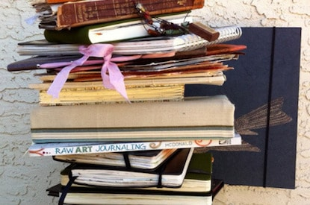
Organizing your week ahead with a planner may incidentally give you things to look forward to and be grateful for, but chances are there will be some events or responsibilities you are NOT so grateful for in your planner. Likewise, you will probably write down both positive and negative events from your day in a diary, meaning that the focus is not solely on what is good or helpful in your life. Finally, a notebook generally includes value-neutral notes and reminders, rather than lists of the good things in your life.
The gratitude journal is unique in this respect – it is the only item in the range of similar notebooks, planners, and journals that are solely dedicated to noticing and appreciating the positive things in your life. To get the maximum out of your gratitude journaling practice, try to keep it this way.
It’s not inherently bad to write down the negative things that happened or the challenges you faced during your day, but unless you are grateful for it, don’t write it down in your gratitude journal. Keeping your gratitude journal a place for only grateful thoughts will help you realize the benefits of a regular gratitude practice.

Ideas for Items in Your Gratitude Log
Your gratitude journal or log is a personal endeavor that must be unique to you and your life. No one can tell you what makes the cut for you and your particular circumstances, but there are some suggestions that might help if you’re struggling in the beginning.
Brianna Steinhilber of everup.com drafted a list of 20 gratitude prompts that can get you writing about all the things you have to be grateful for. If you’re stuck at the start, at least a few of these prompts should be able to kickstart your gratitude creativity!
- List five small ways that you can share your gratitude today.
- Write about a person in your life that you’re especially grateful for and why.
- What skills or abilities are you thankful to have? (You communicate well, you’re a good cook, you have an uncanny ability to dominate in Fantasy Football. Hey, it’s your journal).
- What is there about a challenge you’re experiencing right now that you can be thankful for? (This is a tough one, but you have learned something or grown from the hardship—how?).
- How is where you are in life today different than a year ago–and what positive changes are you thankful for?
- What activities and hobbies would you miss if you were unable to do them?
List five body parts that you’re grateful for and why. (Those long legs help you reach items on the top shelf … don’t forget the little things).
- What about the city you live in are you grateful for?

- What are you taking for granted about your day to day that you can be thankful for? (Can’t think of any? Your alarm clock, your coffee machine, the paperboy who delivered your newspaper, your friendly neighbor who always says good morning … and that’s before you even leave the house).
- List 5 people in your life who are hard to get along with—and write down at least one quality for each that you are grateful for.
- What materialistic items are you most grateful for?
- Write about the music you’re thankful to be able to listen to and why. (We couldn’t make it five minutes on the treadmill without our beats).
- Who has done something this week to help you or make your life easier and how can you thank them?
- What foods or meals are you most thankful for? (Bacon, egg, and cheese on Monday morning, we’re looking at you).
- What elements of nature are you grateful for and why? (The beach, a starry sky or one speckled with fluffy clouds, the sunset…).
- What part of your morning routine are you most thankful for? (A big stretch before you get out of bed, that warm cup of coffee, a cuddle session with your pet…).
- Write a letter to someone who has positively impacted your life, however big or small.
- What is something you’re grateful to have learned this week?
- When was the last time you laughed uncontrollably—relive the memory.
- What aspects of your work environment are you thankful for? (Supportive co-workers, flexible hours, great snacks in the kitchen…) (Steinhilber, 2015)
If you’re looking for some more specific examples of the items others list in their gratitude journals, check out Oprah’s five items from her personal gratitude journal on October 12, 1996:
- A run around Florida’s Fisher Island with a slight breeze that kept me cool.
- Eating cold melon on a bench in the sun.
- A long and hilarious chat with Gayle about her blind date with Mr. Potato Head.
- Sorbet in a cone, so sweet that I literally licked my finger.
- Maya Angelou calling to read me a new poem (Winfrey, “What Oprah Knows for Sure About Gratitude”).
Since we can’t all be friends with fabulous and inspiring celebrities, here are a few other example items for a gratitude journal:
- The sunrise this morning during your early run or while getting ready for the day.
- A quick text from a loved one simply checking in on you.
- The feeling of slipping into bed with freshly washed sheets.
- Having enough to feed yourself and put a roof over your head.
- Your stress ball, which is so good at calming you down during tense or important phone calls.
- The strawberries you had for lunch today, in the sweet spot between soft and firm.
- Your child’s smile as you tuck them into bed.
- Your Pandora or Spotify playlist that so often plays exactly the song you needed to hear.
- The groceries your significant other brought home from the store (even if they forgot something!).
- The sound of rain falling on your window at night, calming and relaxing you.
- While jumping right in and thinking about what you can write in your gratitude journal is an exciting part of the journey, it can get somewhat less exciting as time goes on. On those days when you no longer feel pumped to write down what you are grateful for, it’s good to be prepared.
These tips for maintaining a gratitude journal can help. Lauren Jessen of the Huffington Post blog has these suggestions:
- Plan to write in your gratitude journal every night for 15 minutes before bed. Set an alarm reminder on your phone or schedule it in your calendar. I’ve found that it is easier to write at night so that I can include things that I am grateful for from that day.
- Keep your gratitude journal by your nightstand so you will see it before going to sleep and remember to jot down what you are thankful for. Your journal may even become a symbol of gratitude so that when you just look at it, you will feel a sense of appreciation.
- Write as many things as you want in your gratitude journal. Writing down 5-10 things that you are grateful for each day is a good number to aim for.
- Your gratitude journal doesn’t have to be deep. What you are thankful for can be as simple as “family” or “the new book or movie I recently enjoyed” or “this morning’s breakfast.” What you are grateful for will differ from everyone else.
- The timing of when you want to write is up to you. While I try to write in my gratitude journal every night, sometimes it becomes every other night. That’s okay. Journal when it feels right for you — the benefits really are worth it. (Jessen, 2015)
Creating a gratitude journal has even become popular enough for its own “WikiHow” page! For step-by-step directions on how to keep a gratitude journal, you can visit the page here.
Finally, I came upon a set of tips for making sure you are getting everything you can out of your gratitude journal practice. Keep these in mind when journaling, and there should be no obstacle in your way that can withstand you!
- Don’t just go through the motions – be conscious about your new “attitude of gratitude.”
- Don’t set a minimum number of things to be grateful for every day – aiming for five things is fine, but accept that there will be some days when you need to gift yourself understanding and flexibility.
- Don’t wait for the “right time.” It’s fine to write something early in the day!
- Elaborate on why you are grateful for the things you write down. This can help you understand what is truly important to you and what you can cut out of your life.
Focus on people rather than things. It’s okay to be thankful for your smartphone or your car, but the joy you receive from important relationships likely dwarfs your fondness for electronics!
- Don’t rush through the process – try to savor the act of journaling.
- Include surprises in your list. Surprises can provoke a greater emotional response than planned activities and can be excellent to look back on when you’re feeling stuck in the rut of routine.
- Keep the negative out of your journal. As we mentioned earlier, the focus on what is good sets the gratitude journal apart from other forms of journaling, note-taking, and diary-writing – try to keep it that way!
- Variety is the spice of life! Try to list new things as much as possible.
- Be creative – even if you don’t think you’re creative. Feel like adding a picture of your significant other instead of making them into a single line? Do it!
- Give it a chance. The common wisdom is that it takes three weeks to establish a new habit, so aim for at least three weeks of daily journaling before making any judgments. The only thing you stand to lose if you don’t take to gratitude journaling is a few minutes a day – hardly a huge loss! (Jensen, “Turn Pain to Joy”)
Armed with these tips, examples, and guidelines, hopefully, you will find it easy to begin and maintain a gratitude journal! Now all you need to do is find the format that works for you.

The Gratitude Bullet Journal
While many people who regularly practice gratitude journaling prefer to separate their gratitude by day or week, others like the final product when listing things they are grateful for in one big block for each month.
This format is referred to as the gratitude “bullet” journal, since each thing you are grateful for is represented as one bullet point in the monthly block. Many who prefer bullet journals still keep these bullets organized by day, although they tend to use the day of the month rather than the day of the week (i.e., “15” rather than “Tuesday the 15th”).
For an example of the gratitude bullet journal, see the pictures below.
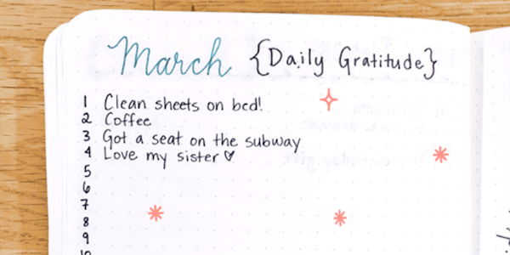

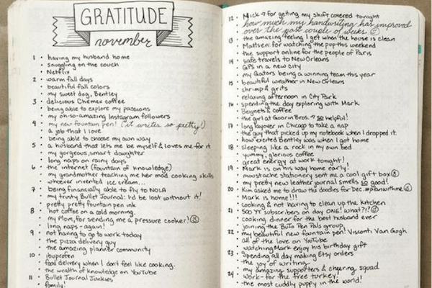

Many who extol the benefits of the gratitude bullet journal recommend listing one thing, or at least one thing, you are grateful for each day, which may make it easier to start if you are struggling to come up with five items each day.
Whether you choose a more traditional log of gratitude or a gratitude bullet journal, what’s important is that you commit to feeling grateful every day and stick with it!
Decorating your journal or adding a personal touch or other stylistic flairs can help you stay motivated, so don’t be afraid to get creative. This journal is for you and only you, so do whatever works for you!

Writing a Gratitude Essay
A gratitude essay is a step further than gratitude journaling – it takes more time, more effort, and more pages (in soft or hard copy!). However, it can have a profound impact on your perspective and spur you to be more mindful and grateful of the good things in your life.
Respected researcher and Journal of Positive Psychology editor Robert Emmons describes his assignment of a gratitude essay as follows:
“Some years ago, I asked people with debilitating physical illnesses to compose a narrative concerning a time when they felt a deep sense of gratitude to someone or for something. I asked them to let themselves re-create that experience in their minds so that they could feel the emotions as if they had transported themselves back in time to the event itself. I also had them reflect on what they felt in that situation and how they expressed those feelings.” (Emmons, 2013)
A gratitude essay is a declaration, a reflection, and an acknowledgment of what you have to be grateful for and, indirectly, who you are. The occasion that you think back to and your reaction to this reflection can reveal a lot about who you are and what you value.
For example, if you look back with deep gratitude on something your mother did for you, full to the brim with self-sacrificing love, you will likely find that you place immense value on family and close relationships with loved ones.
If you reflect back on a helping hand from a teacher, you might be the sort of person who greatly values mentoring, compassion, or the “pay it forward” mentality.
The point is that writing a gratitude essay is not just a great way to acknowledge and reflect on some of the most important or defining moments of gratitude in your life, it is also a way to learn about yourself.
With that in mind, grab a pen or a keyboard, get to thinking about something you are grateful for, and prepare yourself to learn!
Printable Journal Templates - There are countless templates out there for you to base your gratitude journal on. To save you the time of looking through hundreds of templates, I narrowed it down to five different printable templates you can use for your own journal.
Of course, if none of these fit your personal style, there are many others just a few clicks away. As always, find what works for you!

The Grateful Journal
This template is intended for those who would like to meld their gratitude practice with their religious or spiritual beliefs. If you are not looking for mentions of a specific religious figure or deity, continue on for more templates!

Gratitude Journal (go to website to download)
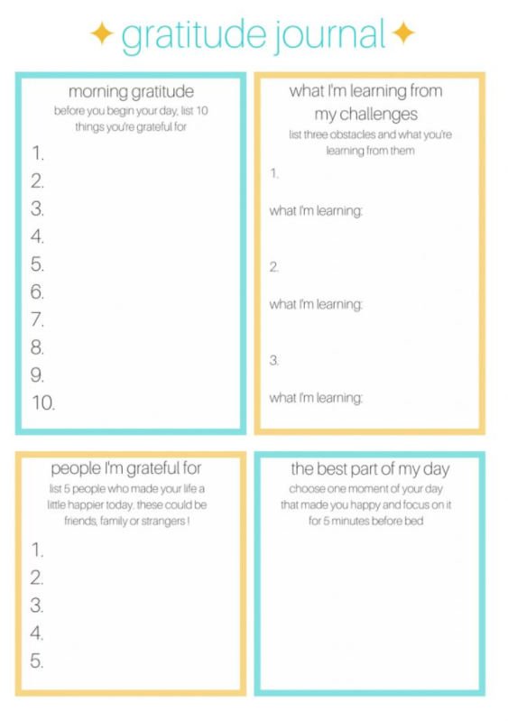
For a bare-bones design that you can keep neat and uncluttered (or doodle in the margins – your choice!), try the gratitude journal worksheet from therapistaid.com. This worksheet includes space to list five things you are grateful for each day of the week (Monday through Sunday), as well as a space at the end to note the highlights of your week.

Gratitude Journal, Four Parts
This is a different design than we have discussed so far, but it’s a fun one! It splits the sheet into four parts, with a part dedicated to morning gratitude (listing things you are grateful for right at the beginning of your day), one corner for writing down what you are learning from challenges in your life, one part to list the people you are most grateful for today, and the final piece dedicated to describing the best part of your day. This is a fun and unique way to make every day a gratitude-filled one!

Gratitude Bullet Points
If you’re partial to the bullet points style, you may like this template. It includes four separate week columns with space for three things you are grateful for each day. One nice thing about this template is that you can start your week on whichever day works for you since the days are labeled “Day 1” through “Day 7” instead of Sunday through Monday.

Gratitude Journal, Etsy
If you feel like supporting an independent business owner, there is a great template available for purchase on Etsy. The instant download is only $3.57 and includes space to note what you are grateful for each day of the week as well as space to explain why you are grateful for each item. They also have other versions that you may be partial to. Head on over to support a crafty individual and begin your gratitude journey at the same time!

5 Gratitude Journal Apps That Can Help
As with most problems or tasks in life, there is now an app for that!
If you prefer the feel of a touchscreen over a pen in your hand, there are plenty of apps that support your daily gratitude practice.

Gratitude / Bliss Journal
For example, the Gratitude Journal or Bliss Journal is an old standby in the area of gratitude journal apps. It is available for Android devices and takes up only a tiny sliver of your phone’s memory. Best of all, it’s free to install!
If you’re looking for an app that will guide you through your daily gratitude practice with helpful exercises and prompts, click here to learn more about or download this app.

Gratitude Journal
Mojo
This Gratitude Journal app is available for download from iTunes, with versions that are compatible with the iPhone and iPad. This app will only set you back $2.99 and 45 MB of space, but it packs a powerful punch. It aims for a distraction-free and easy-to-use interface, with easy scrolling and syncing on all iOS devices.
Bonus points – it also uses little heart symbols to track what you are grateful for each day! To see the hearts for yourself or download this app, click here.

Mojo
Mojo adds a few fun features to the typical gratitude journal app, including adding pictures, emojis, and organizing by the calendar. This fun and easy app can even import your entries from the Gratitude app to keep all of your gratitude synced!
This app, marketed as “more than a journal”, can be found on iTunes. It seems that the app is currently struggling to find a home page for downloading, but you can learn more about it here.

Gratitude 365 Pro
This gratitude journal app is available for iPhone and allows the user to incorporate photos, track their journaling by day, and organize with email, Facebook, Twitter, or Flickr calendar.
It’s all in the name with this app, so give it a try if you plan on adding gratitude to your daily practice, 365 days a year! You can read more about it or download it for just $1.99 here.

Day One
Another app for iPhone, iPad, and Mac users, Day One helps you keep a digital diary complete with pictures, maps, and notes about your day. This app can cut across devices, presenting you with the same look and format for each platform.
While this app is intended for more of a diary or daily journal purpose, it is easy to use it for tracking your gratitude. You can find it for Mac at $9.99 or fore iPhone and iPad at $4.99 in the iTunes store. Click here to learn more about this app.

A Take Home Message
Starting up a new hobby or practice can be difficult, especially when it’s a practice that can dig up some pretty intense feelings. Don’t be alarmed if you find it to be a difficult, overwhelming, or highly emotional experience at first. Try to push through the discomfort and keep your commitment to daily gratitude, because greater peace and contentment lie on the other side! Have fun with your gratitude journal, and remember to make it uniquely “you!”
About the Author
Courtney Ackerman is a graduate of the positive organizational psychology and evaluation program at Claremont Graduate University. She is currently working as a researcher for the State of California and her professional interests include survey research, well-being in the workplace, and compassion. When she’s not gleefully crafting survey reminders, she loves spending time with her dogs, visiting wine country, and curling up in front of the fireplace with a good book or video game.
https://positivepsychologyprogram.com/gratitude-journal/
______________________________________________________________________________

2nd article

12 surprising benefits of writing down your thoughts and feelings
There are many reasons why we sometimes don’t know what to do next. You may feel completely overwhelmed because you have too many responsibilities; you might feel vaguely uneasy for no apparent reason; you might feel that you can do better than your current career track, but you don’t know how.
There’s a very simple trick you can follow to sort out your frazzled mind and deal with life’s endless demands and distractions that keep you from discovering how best to live your life.
It won’t cost you anything and it requires no special effort.

Here’s what you do: write everything down.
Take a piece of paper and write everything down that’s going on in your life — things you are worried about, every task, large and small, all projects, social obligations, projects you have to do, promises you have to keep. From doing the dishes to doing presentations and everything in between.
The trick is not to write things down in order to sort out your mind – just write everything down indiscriminately.

Why does writing down anything that comes to mind work?
When you write it down, something takes over and the writing becomes more serious and more purposeful.
It’s like magic. In a short while the mind calms down and reorganizes. It probably because in the process of writing, feelings and emotions become clearer and hidden thoughts and feelings come to the surface to bring a more complete light to the situation.
In due time, what’s really bothering you, what has been obscured by incessant worrying and obsessive repetition of the same thoughts, comes to the surface as clear as daylight.
In particular, writing things down produce these six beneficial results.

1. It clears your mind and readies it for decision-making
This exercise helps the mind to center and reorganize all those spiraling thoughts that leave you in a fog. You’ll notice a picture emerging of the real issue at hand.
You’ll be able to gain insights because you’ve literally emptied your mind of clutter. Doing this prepares your mind for more important thinking.
2. It clarifies underlying emotions

Writing down what’s on our mind is a meaningful and effective way to process your feelings. Life is complicated and people are complicated. Things happen and sometimes one is so caught up in the moment that you can’t see the wood for the trees.

Writing down your thoughts on an issue is a way to get to your feelings. The more your write, the closer you get to the core feeling at work that’s preventing you from knowing what you really want in life or knowing what’s holding you back.

3. It gives you a record of your development.

If you choose to keep an account of your writing somewhere it can serve as a record of your personal development over time. You can refer back to it and remind yourself of previous insights that have helped you in difficult situations.
You might notice a thread running through your writing which could very well serve as the basis for a self-help book. Wouldn’t that be something?

4. You gain a sense of fulfillment
It is extremely satisfying when writing down your thoughts and feelings results in insights into yourself, other people and situations. You grow in personal wisdom that can serve you, and others, for the rest of your life and that is very fulfilling.
You become an asset to society because you are growing in self-awareness.

5. It helps you to enter the unknown
When you write things down, you set a process in motion that is pure magic — you enter a world of possibility.
The very act of writing everything down unconditionally allows you to explore your wildest dreams, and your most treasured ambitions, opening your mind to untold possibilities which you simply can’t notice when you’re overwhelmed and fretting.

6. It helps you to take action
There is something about writing thoughts down and not just living with them in your head that solidifies them. They stare up at you from the page and demand action because you’ve put them in the open.
Writing down your thoughts, your plan of action, your ideals and goals for yourself give them the beginnings of live. It’s the first step in making them become reality. And that first step makes it more likely that you will commit and take action in which case you’ll make your dreams come true.

7. Writing makes room for higher levels of thinking to take place
By getting the details and right-now thoughts out of your head on a regular basis, you make room for better, higher-level thoughts.
This means that your brain has room to breathe and you will have more room for great ideas, grand ideas, and solutions to problems that might have even been plaguing you for some time.

8. Writing gives you time and space to process deep-seated emotions
It’s important to spend time writing about your emotions because you’ll come to discover that your emotions are just brought on by thoughts in your head. When you write and are able to get those thoughts out of your head, your bi-product, sometimes negative emotions, go with them.
This means that you won’t be bogged down by heavy thoughts and feelings that leave you feeling uninspired or motivated. We all have way too many thoughts in our brains at any given time. Let some of them out by getting them onto paper.

9. Writing lets you tell your story
We all have amazing stories to tell, but what’s more important than telling a story? Crafting your own understanding of your story. Getting to know yourself through your writing can be incredibly transformative and can help you to find yourself in a new way.
There’s no limit to what you can discover about yourself if you are willing to keep digging. Remember that you don’t have to share any of this information with anyone, so you are free to craft a story that suits your dreams and needs.

10. Writing helps you to feel like you’ve accomplished something
Here’s the thing about writing: when you put pen to paper and see the product of your efforts, you’ll automatically feel better about yourself.
Even if you were writing about a horrible experience, just the act of getting the thoughts out of your head will free your mind to focus on bigger and better things. If you feel stuck, write. If you feel happy, write.
There’s no right or wrong way to do this kind of exercise. The point is to just start.

11. Writing lets you dream bigger than you would if you were saying things out loud
Because nobody is going to read your writing unless you are sharing it on a blog, you never have to worry about someone judging you or saying your dreams are stupid.
Just don’t make the mistake of writing out everything you want in life and then telling yourself it’s stupid. It’s not stupid. Humans are very good at telling ourselves our dreams don’t matter.
But when you put your dreams on the paper, you give them life in a different way and you never know where that might lead.

12. Writing helps you create a routine in your life
Try starting each day or ending every night with a few minutes of writing. Whether you want to write about your gratitude or your dreams, taking time to clear your mind can be really beneficial to you and those around you.
When your brain is not cluttered, you are happier, healthier, and more productive. It’s a win-win situation, so give it a try today and find out for yourself why writing is still cool.

In Conclusion
If you aren’t already journaling or writing on a regular basis, you’ll want to start ASAP. That’s because the act of writing to get your thoughts out of your head and onto paper can literally transform your life.
And when you see the positive transformations and changes that happen in your life when you start to work through things through your writing, you want to more of it, more often, and for longer periods of time.
Anyone who has made something of themselves or created something in the world will tell you that they make time to write, even if it is just for themselves, on a regular basis.
The most popular form of writing for personal use is journaling. A lot of people still create blogs for others to read. Whatever you decide, just decide to start writing.

https://ideapod.com/6-surprising-benefits-writing-thoughts-feelings/

