Dave Dodge, L.C.S.W.
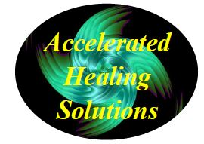
Helping People Get Better Faster

128 Radio Circle Mt. Kisco, N.Y. 10549

dave@acceleratedhealingsolutions.com (914) 242-3484

www.AcceleratedHealingSolutions.com www.BrainspottingSpecialist.com

_______________________________________________________________________________________________________________________________________

The Emotional Guidance Scale

The following is a list of emotions that will help you to identify, 1) What your baseline emotional state is and 2) Where you are emotionally and where you want to go to get to more Love, Joy, etc.

After you have identified your emotional baseline, try to identify what thoughts are holding you in that emotional state and what can you do to change those thoughts into more positive ones.

Where are you on this Emotional Scale?

1. | Joy/Appreciation/Empowered/Freedom/Love
2. | Passion
3. | Enthusiasm/Eagerness/Happiness
4. | Positive Expectation/Belief
5. | Optimism
6. | Hopefulness
7. | Contentment
8. | Boredom
9. | Pessimism
10. | Frustration/Irritation/Impatience
11. | Overwhelmed
12. | Disappointment
13. | Doubt
14. | Worry
15. | Blame
16. | Discouragement
17. | Anger
18. | Revenge
19. | Hatred/Rage
20. | Jealousy
21. | Insecurity/Guilt/Unworthiness
22. | Fear/Grief/Depression/Despair/Powerlessness

From the book “Ask and It is Given”, pg. 114

